Ideation Phase
Empathize & Discover

Date | [DD Month YYYY]
Team ID | [Team ID]
Project Name | Automated Network Request Management in ServiceNow
Maximum Marks | 4 Marks

Empathy Map Canvas:
An empathy map is a simple, easy-to-digest visual that captures knowledge about a user’s behaviours and attitudes.

It is a useful tool to helps teams better understand their users.
Creating an effective solution requires understanding the true problem and the person who is experiencing it. The exercise of creating the map helps participants consider things from the user’s perspective along with his or her goals and challenges.

Reference: https://www.mural.co/templates/empathy-map-canvas

Empathy Map: Automated Network Request Management in ServiceNow
Persona: a requester who needs a new network connection or a change to an existing one, and who raises the request through the organisation's ServiceNow instance. The map was prepared by the project team from its analysis of the manual request process and of the implemented solution; it is not based on formal customer interviews.
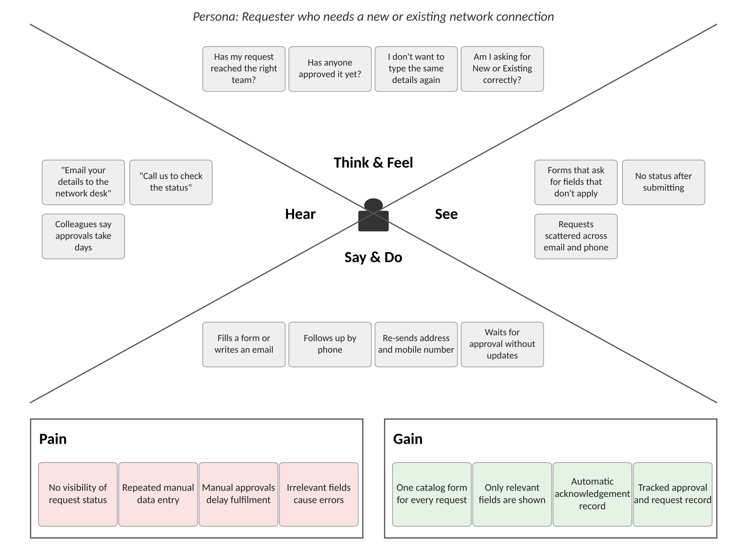
Figure 1: Empathy map — Network service requester
Key insight: the requester's main pains are lack of status visibility and repeated data entry. The solution answers these with a single catalog form, dynamic fields, pre-filled requester details, and an automated record, approval and acknowledgement. Delivery of the acknowledgement email still depends on SMTP configuration.

